Wolfson College

University of Oxford

Founded 1966

Welcome to Wolfson College

We are delighted to have you as our guest, and hope that your time here will be both pleasurable and productive. Our staff will do all they can to make you comfortable for the duration of your visit. This guest information guide identifies the services and amenities available to you.

Wolfson’s beautiful location allows you to enjoy the City of Oxford and also the peace of a quiet retreat. Please feel free to explore the gardens, and relax. As one of Oxford’s few graduate-only colleges, we have students living and studying on site year-round. During your stay, we invite you to respect their community and expect them to respect you.

We are always working to improve our guests’ experience, and encourage you to give us your feedback on the comment form provided. Before you leave, please drop it in the comment box in the Lodge.

Have a wonderful visit to Oxford!

Wolfson’s History
In 1965, the University founded Iffley College in order to provide for members of its academic staff who held no college fellowship. In 1966, Sir Isaiah Berlin, then Fellow of All Souls and Chichele Professor of Social and Political Theory, was invited to be the College's first President. Through his efforts, generous benefactions were received from the Wolfson Foundation and the Ford Foundation, which enabled the College, now renamed as Wolfson, to make provision for graduate students also. The first of these were admitted in October 1968. The College's buildings, designed by architects Powell and Moya, were ready for occupation in 1974. The College received its Royal Charter in 1981. The College's democratic structure, egalitarian ethos and general friendliness owe much to the inspiration and leadership of Sir Isaiah Berlin.

A Short History by Frank Jessup, revised by Stuart McKerrow and Jane Potter, gives a detailed account of the College's foundation and its early years and may be purchased from the Lodge

Wolfson College is a member of Conference Oxford, the central conference marketing office for the University of Oxford.

Layout of the Grounds

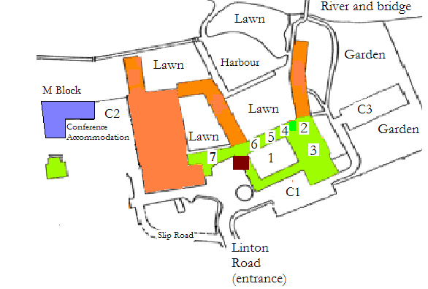
- Berlin Quad
- Haldane Room
- Hall
- Private Dining Rooms and Coffee Room
- Florey Room
- Committee Room
- Buttery
■ Lodge
C1 West Car Park
C2 North Car Park
C3 South Car Park

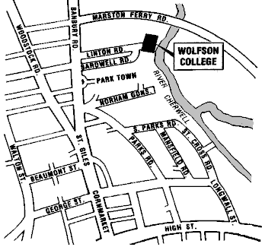

⬇
Oxford city centre

Accommodation (M Block)

Keys and access
The key issued to you on arrival operates the M Block front door and also the door to your room. The building can be accessed 24 hours a day.
There is a charge of £25 + VAT for lost or unreturned keys, which will be invoiced to your conference organiser.

Security
Please ensure that the main entrance door is closed when entering or leaving the building. Lock your room door at all times and secure windows whenever you are leaving your room.
Safes are provided for valuables. The College cannot take any responsibility for the loss or damage of any items whilst in College accommodation.
Please report any incidents to the College Lodge (ph. 01865 274100 or ext.74100) or the local police (0845 850 5505).

Linen and towels
Towels are changed if required on a daily basis. Please leave any towels that require changing on the floor in the shower room.

Room Cleaning
Rooms are checked and beds made on a daily basis.

Irons
There is an iron and ironing board in each communal kitchen. For your safety, please ensure that the ironing board is correctly erected for use, and put away afterwards. The iron must be placed safely back in the store rack after use.

Communal Kitchens
Guests are welcome to use the kitchens, but please keep them tidy.
The communal kitchen has a kettle with a supply of tea, coffee and milk.

Check Out Procedures
Check-out time is 10am. Baggage may be stored in the Lodge, or, if there is a large quantity, a room nearby. Please return your room key and any parking permits to the Lodge to complete the check-out.

The Lodge
The Lodge is the centre point for the public face of the College

Opening Hours
The Lodge is open 9.00am until 11.00pm seven days a week and overnight from 11.00pm until 9.00am for emergencies only.

Messages
A board is available in the Lodge area for messages for Conference guests.

Mail
Mail can be taken to the Lodge for collection by the Post Office. The post is collected at 4.30pm every day.

Sales
The Lodge sells a number of items:

Postage stamps
Wolfson College Postcards
Plain paper
Transparencies
Envelopes
Pens
Whiteboard markers
USB memory sticks
Ethernet (internet) cables

Toilet rolls
Tampax are available in the ladies toilets

Milk (limited supplies)
Teabags
Coffee sachets
Sugar sachets
Orange juice

Souvenir Wolfson College Garden Guide
A Short History of Wolfson College

Fault Reporting
Please report any room fault to the Lodge.

Fax Machine
A fax machine is available at the Lodge for incoming and outgoing faxes. Charges per page are: 30p for outgoing UK faxes, 40p for faxes to Europe, and a 75p charge for other international faxes.
To receive faxes, the number is 01865 274125.

Photocopier
To use the photocopier, purchase a photocopy credit card from the Lodge.
Cards are available as follows: 35 copies £2.00, 100 copies £5, 200 copies £10.

Lost and Found
Lost property is held in the Lodge for collection.

Disabled Access and Facilities
If you are a person with a disability and require special assistance, please ask at the Lodge.

Disabled toilet
There is a publicly accessible disabled toilet (see map). A ‘Radar’ key is needed to access the toilet. If you do not have one, please go to the Lodge.

Parking Permits
If you are parking on the College site, your vehicle must display a parking permit. This is issued with your room key.
Please note that the College cannot take responsibility for theft from or damage to any vehicle parked in the College grounds.

Telephones
Lodge A public payphone booth is located in the rear of the Lodge beyond the pigeonholes.

M and C Block External calls cannot be made from the telephone in your room, but it can be used to contact the Lodge by ringing 74100. The answering service should have been deactivated prior to your arrival. If the phone rings intermittently however, there may be a message for the room’s previous occupant. To deactivate, dial 12*, wait for the tone, hang up. Then dial 13*, wait for the tone and hang up.

Email and Internet
All bedrooms have internet linkage. Your logon and password (case sensitive) are enclosed in this pack.

No Smoking Policy
Smoking is prohibited in all internal areas of Wolfson College, and in all substantially enclosed outdoor areas.

Noise/Music
Please keep noise and the playing of music to a reasonable level. Music should be off by midnight. If you are returning to the accommodation in the evening please do so quietly and respect the other users of the College.

Alcohol
Please consume any personal alcoholic beverages only in the privacy of your room.

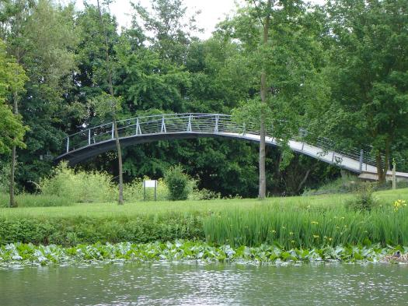
Recreation

Shops, Newsagents, Chemists, Bars
The nearest shops are situated in Summertown, just north of Marston Ferry Road. There are a number of restaurants, a pub, a wine café, newsagents, chemists, and dry cleaners. The main shopping areas can be found in the city centre.

Swimming and Workout Facilities
The Marston Swimming Pool and Gymnasium (ph. 01865 467060) is located adjacent to the Summertown shopping center. Schedules and hours of operation may be obtained from the Lodge. The facility has a handicap-accessible swimming pool, weight room, and cardio and circuit-training machines.

Television
A television is available in the East Common Room, opening off the Berlin Quad, just near the Hall.

Towpath Walks
You may use the towpath along the River Cherwell, and walk in the meadows. Just cross the bridge in the College grounds to get there.

Outdoor Recreational Equipment
Punts may be hired from the Cherwell boathouse (Ph. 01865 552746), just around the corner from College. Go into Chadlington Road, walk along on the left hand side, and you will see the driveway to the Boathouse.

Area Events & Information
Some bus guides and local tourist information materials are available free of charge in the Lodge. For further help, search online or contact Oxford Tourist Information Centre (ph. 01865 726871,
email: tic@oxford.gov.uk, http://www.oxford.gov.uk/tourism/index.cfm).
For details of local information, movies, etc. www.dailyinfo.co.uk

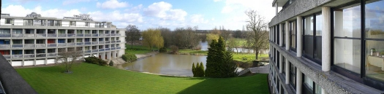

Transport

Information
Some bus guides and local tourist information materials are available in the Lodge. Further assistance is available from the Oxford Tourist Information Centre (ph. 01865 726871, email: tic@oxford.gov.uk, http://www.oxford.gov.uk/tourism/index.cfm).

Wolfson Bus (Monday – Friday only)
30p per ride. Correct fare please.
Maximum: 16 passengers. Priority is given to College members.
The bus stop is located in front of the Lodge.
Depart
Wolfson | 12.00 | 12.20 | 12.40 | 13.00 | 13.20 | 13.40 | 14.00 | 14.20
Keble/Parks Road | 12.05 | 12.25 | 12.45 | 13.05 | 13.25 | 13.45 | 14.05 | 14.25
Broad Street (Oxford Centre) | 12.10 | 12.30 | 12.50 | 13.10 | 13.30 | 13.50 | 14.10 | 14.30
Mansfield Road | 12.12 | 12.32 | 12.52 | 13.12 | 13.32 | 13.52 | 14.12 | 14.32
Keble/Parks Road | 12.14 | 12.34 | 12.54 | 13.14 | 13.34 | 13.54 | 14.14 | 14.34

Public buses
Buses run frequently along the Banbury Road, to and from the city centre. Look for the number 2, and 7 busses. The trip costs £1.20 in either direction. When returning to Wolfson College, ask for the St Margaret Road stop.

Taxi telephone numbers:

ABC 01865 770077
01865 775577

Radio taxis 01865 242424
City Taxis 01865 794000
01865 201201
001 Taxis 01865 240000
Royal Cars 01865 778866
01865 777333
Euro Taxis 01865 430430

Bicycles
Call Summertown Cycles on 01865 316885 for bicycle hire.

Emergency Procedures
The direct number for emergency services is 999.
Emergency services will arrive at the Lodge, and will need guidance to the appropriate part of the College, it is essential that you also contact the Lodge (01865 274100, or 74100 from any internal phone) in the event of an emergency.

If you discover a fire
- Raise the alarm by operating the fire alarm system break glass in the red boxes. These are positioned near all exits to the building.

- Leave the building by the nearest exit and close all fire doors behind you. The main corridor fire doors (M Block) will close automatically when the fire alarm is activated.

- Do not stop to collect personal belongings

- Inform the Lodge and the fire service that this is not a false alarm.

- Make your way to the designated fire assembly point and wait until you are told by the fire services or a member of the College that it is safe to re-enter the building.

If You Hear an Alarm
- Leave the building quickly and safely by the nearest available fire exit.

- Do not stop to collect personal belongings

- Make your way to the Lodge and wait until you are told by the fire services or a member of the College that it is safe to re-enter the building.

Before leaving your room
  - Feel the door for heat and check the bottom of the door for smoke. If the door is hot, do not open it.
  - If smoke is visible in the corridor, remain in your room.
  - If smoke is entering your room, place wet towels or sheets around the door to prevent the smoke from entering and open the window to obtain fresh air.
  - Call the Lodge and tell us your room number.
  - Hang a towel from the window to identify your location.

Heat and smoke detectors have been installed throughout College. To operate effectively, and to avoid false alarms, it is important that fire doors remain shut.

First Aid and Sickness
For First Aid or in case of an emergency, contact the Lodge (01865 274100).

